DATE | Monday | Tuesday | Wednesday | Thursday | Friday
WEEK 1 | PAPA JOHNS PIZZA (1EA)  VEG.-BROCCOLI (3/4 cp)  FRUIT-MIXED FRUIT (1/2cp)  GRAIN-INCLUDED IN ENTRÉE  RANCH (1oz)  MILK (6oz) | FRESH BEEF TACO (2oz)  VEG.-PINTO BEANS (3/4cp)  FRUIT-CANTALOUPE (1EA)  GRAIN- TORTILLA (1EA)  SHREDDED CHEESE (1oz)  MILK (6oz) | BACON GRILLED CHEESE (1EA)  VEG.-CARROTS (3/4 cp)  FRUIT-CINN. APPLE SLICES (1/2 cp)  GRAIN-INCLUDED IN ENTRÉE  MILK (6oz) | CHICKEN FRIED STEAK (1EA)  VEG.-MASH POTATOES (3/4 cp)  FRUIT-PEACHES (1/2 cp)  GRAIN-BISCUIT (1EA)  MILK (6oz) | BBQ RIBETTE (1EA)  VEG.-MIXED VEGETABLES (3/4 cp)  FRUIT-APPLE (1EA)  GRAIN-WG BUN  MILK (6oz)
WEEK 2 | CHEESEBURGER (1EA, 1 SLICE CHEESE)  VEG.-BAKED BEANS (3/4cp)  FRUIT-MIXED FRUIT (1/2cp)  GRAIN- HAMBURGER BUN (1EA)  MUSTARD, KETCHUP, PICKLES (1oz)  MILK (6oz) | CHICKEN AND RICE (3/4CP)  VEG.-CARROTS (3/4 cp)  FRUIT-MANDARIN ORANGES (1/2 cp)  GRAIN-SALTINE CRACKERS (2EA)  MILK (6oz) | SPAGEHETTI (3/4CP)  VEG.-BROCCOLI (3/4 cp)  FRUIT-FRESH FRUIT (1EA)  GRAIN- BREADSTICK  MILK (6oz) | FRENCH TOAST STICKS  (3 EA)  VEG.-TATOR TOTS (3/4 cp)  FRUIT-PEARS (1/2 cp)  SAUSAGE (1 EA)  GRAIN- INCLUDED IN ENTREE  MILK (6oz) | CHICKEN NUGGETS (5EA)  VEG.-MIXED VEGETABLES (3/4 cp)  FRUIT-ORANGE (1EA)  GRAIN-RICE (1/2 cp)  ORANGE SAUCE (1oz)  MILK (6oz)
WEEK 3 | PAPA JOHNS PIZZA (1EA)  VEG.-CARROTS (3/4 cp)  FRUIT-PINEAPPLE (1/2 cp)  GRAIN-INCLUDED IN ENTRÉE  RANCH (1oz)  MILK (6oz) | 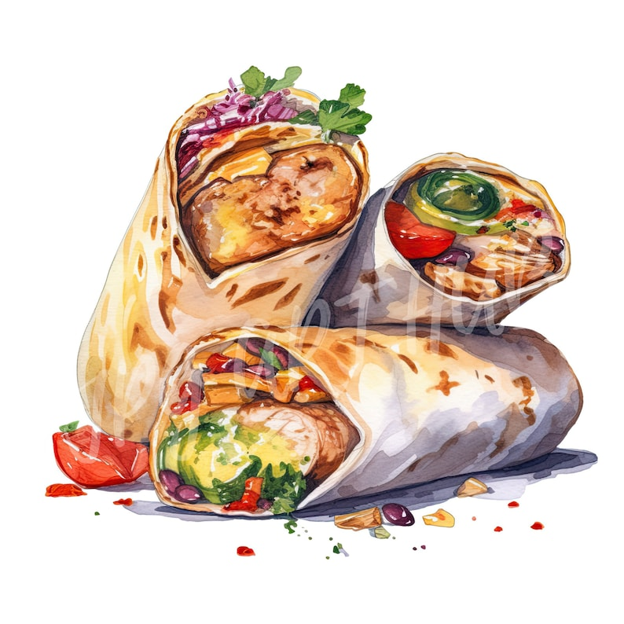  CORN DOG (1EA)  VEG.-CELERY (3/4 cp)  FRUIT-MIXED FRUIT (1/2cp)  GRAIN- ROLL (1EA)  MILK (6oz) | FRITO PIE (2oz, CHIPS 1oz)  VEG.-CORN (3/4 cp)  FRUIT-MANDARIN ORANGES (1/2 cp)  GRAIN-TORTILLA (1EA)  SHREDDED CHEESE (1oz)  MILK (6oz) | BOW TIE CHICKEN ALFREDO (3/4CP)  VEG.-BROCCOLI (3/4 cp)  FRUIT-APPLESAUCE (1/2cp)  GRAIN- GARLIC BREADSTICK (1EA)  MILK (6oz) | 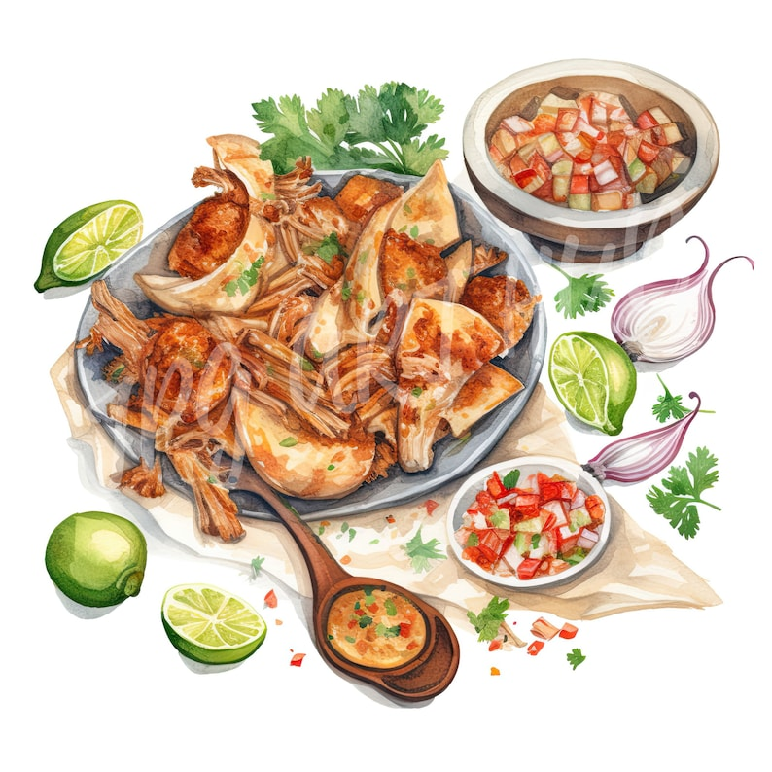  TAMALES (1EA)  VEG.-PINTO BEANS (3/4cp)  FRUIT-PEACHES (1/2 cp)  GRAIN-INCLUDED IN ENTREE (1EA)  MILK (6oz)
WEEK 4 | CHICKEN PATTY (1EA)  VEG.-BROCCOLI (3/4 cp)  FRUIT-FRESH FRUIT (1EA)  GRAIN-HAMBURGER BUN (1EA)  SLICE CHEESE (1ea)  MILK (6oz) | SOFT CHICKEN TACO (2oz)  VEG.-PINTO BEANS (3/4cp)  FRUIT-FRESH FRUIT (1EA)  GRAIN-TORTILLA (1EA)  SHREDDED CHEESE (1oz)  PICANTE SAUCE (1oz)  MILK (6oz) | SALISBURY STEAK (1EA)  VEG.-WHIP POTATOES (3/4 cp)  FRUIT-MIXED FRUIT (1/2cp)  GRAIN-DINNER ROLL (1EA)  BROWN GRAVY (1oz)  MILK (6oz) | CHICKEN POSOLE (3/4 CP)  VEG.-FRESHCARROTS (3/4 cp)  FRUIT-FRESH FRUIT (1EA)  GRAIN-TORILLA (1 EA)  MILK (6oz) | BEAN BURRITO (1EA)  VEG.-GREEN BEANS (3/4cp)  FRUIT-MANDARIN ORANGES (1/2 cp)  GRAIN-INCLUDED IN ENTREE  PICANTE SAUCE (1oz)  MILK (6oz)
LUNCH MENU 2023-2024

Your cafeteria is managed by
Canteen of Central New Mexico an equal opportunity employer

