DATE | Monday  Your cafeteria is managed by  Canteen of Central New Mexico an equal opportunity employer | Tuesday | Wednesday | Thursday  Breakfast Menu 2023-24 | Friday
WEEK 1 | WG CEREAL (1 EA)  FRUIT JUICE (1EA)  MILK (8OZ-1EA) | PANCAKE BOWL  (1 EA)  FRUIT (1EA)  MILK (8OZ-1EA) | MINI CINI (1EA)  SLICED BREAD (1EA)  FRESH FRUIT (1EA)  MILK (8OZ-1EA) | EGGO FRENCH TOAST (3EA)  FRUIT JUICE (1EA)  MILK (8OZ-1EA) | DONUT HOLES (1EA)  JELLY (1EA)  FRESH FRUIT(1EA)  MILK (8OZ-1EA)
WEEK 2 | WG CEREAL (1 EA)  FRUIT JUICE (1EA)  MILK (8OZ-1EA) | YOGURT (1EA)  GRANOLA BAR (1EA)  FRUIT (1EA)  MILK (8OZ-1EA | BANANA BREAD (1EA)  FRESH FRUIT (1EA)  MILK (8OZ-1EA) | CEREAL (1EA)  FRUIT JUICE (1EA)  MILK (8OZ-1EA) | WG BAGEL (1EA)  CREAM CHEESE (1EA)  FRESH FRUIT(1EA)  MILK (8OZ-1EA)
WEEK 3 | WG CEREAL (1 EA)  FRUIT JUICE (1EA)  MILK (8OZ-1EA) | BOILED EGG (1EA) TORTILLA (1EA)  FRUIT (1EA)  MILK (8OZ-1EA) | YOGURT (1EA)  FRESH FRUIT(1EA)  GRAHAM CRACKERS (1EA)  MILK (8OZ-1EA) | WAFFLES (1EA)  FRUIT JUICE (1EA)  MILK (8OZ-1EA) | MINI CINI (1EA)  FRESH FRUIT(1EA)  MILK (8OZ-1EA)
WEEK 4 | WG CEREAL (1 EA)  FRUIT JUICE (1EA)  MILK (8OZ-1EA) | GLAZED PANCAKES (1 EA)  FRUIT (1EA)  MILK (8OZ-1EA) | 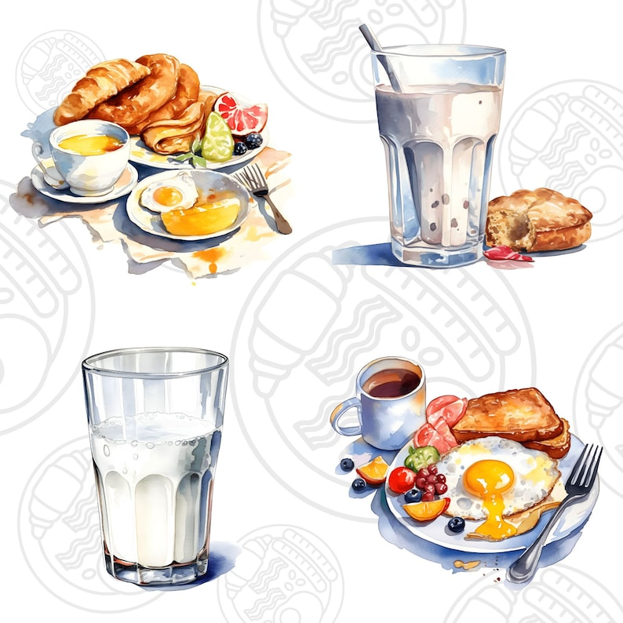  ZUCCHINI BREAD (1EA)  FRESH FRUIT (1EA)  MILK (8OZ-1EA) | EGGO FRENCH TOAST (1EA)  FRESH FRUIT(1EA)  MILK (8OZ-1EA) | FRUIT FRUDEL(1EA)  SLICED BREAD (1EA)  FRUIT JUICE(1EA)  MILK (8OZ-1EA)

